NAME: ________________________________________

**ECE 111**

**EXAM 1**

**Fall 2013**

FOR GRADERS’ USE ONLY.

|  |  |  |
| --- | --- | --- |
| PROBLEM # | GRADE | POINTS |
| 1 |  | 16 |
| 2 |  | 42 |
| 3 |  | 38 |
| 4 |  | 8 |
| TOTAL |  | 104 |

1. (16 points total)

Given simple circuit elements with voltages across and currents through them as shown below, what power are they dissipating? Be sure to follow the Passive Sign Convention.

A. (4 points)

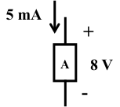 PA = ____________________________

B. (4 points)

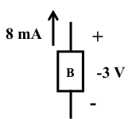 PB = ____________________________

C. (4 points)

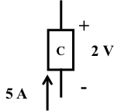 PC = ____________________________

1. (4 points)

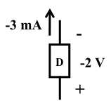 PD = ____________________________

2. (42 points total)

Given the circuit below, use Node Voltage Analysis to find the voltage across the 10kΩ resistor, VO.

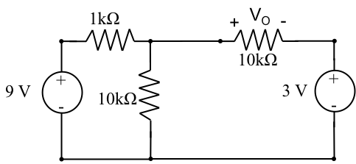

A.) (6 points) Label the nodes on the diagram (A, B, C, etc) and designate one as reference.

B.) (3 points) Write the desired result in terms of the Node Voltages.

C.) (8 points) Can any node voltages be found by inspection? If yes, what are they?

D.) (10 points) Write the Node equations needed. (YOU WILL SOLVE THEM ON THE NEXT PAGE.)

E.) (10 points) Solve these equations for the necessary node voltages.

F. (3 points) Find VO. (Be sure to draw a box around your answer.)

G. (2 points) If I doubled the magnitude of BOTH voltage sources to 18 and 6 volts, respectively, what would the output voltage change to?

3. (38 points total)

Given the same circuit below, use Mesh Analysis to find the voltage across the 3kΩ resistor, VO.

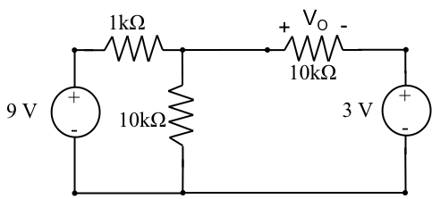

A.) (6 points) Label the meshes on the diagram.

B.) (4 points) Write the desired result in terms of the Mesh Currents.

C.) (8 points) Can any mesh currents be found by inspection? If yes, what are they?

D.) (10 points) Write the Mesh equations needed and reduce . YOU WILL SOLVE THEM ON THE NEXT PAGE.

E.) (10 points) Find VO. (Be sure to draw a box around your answer.)

4. (8 Points Total)

A. (4 points) Given this Practical Voltage Source, what is its Equivalent Practical Current Source?

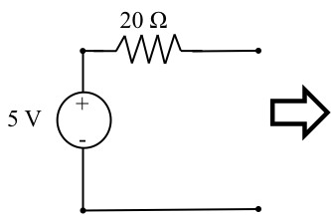

B. (4 points) Given this Practical Current Source, what is its Equivalent Practical Voltage Source?

